Feature detection
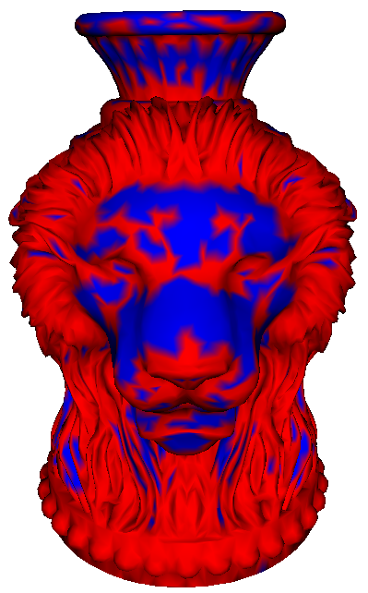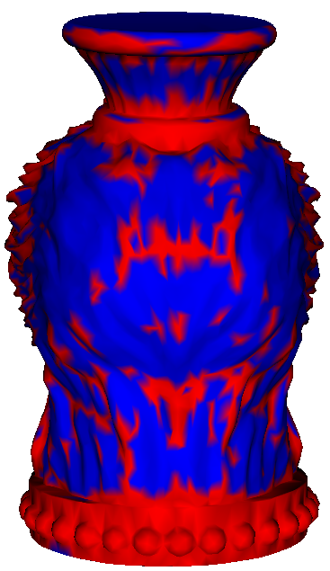
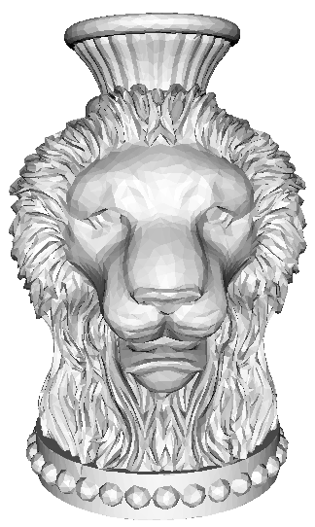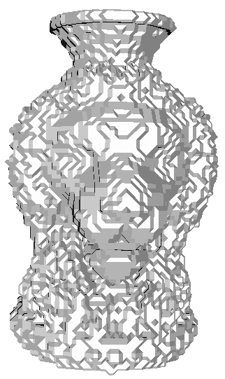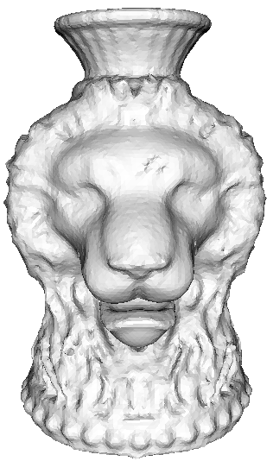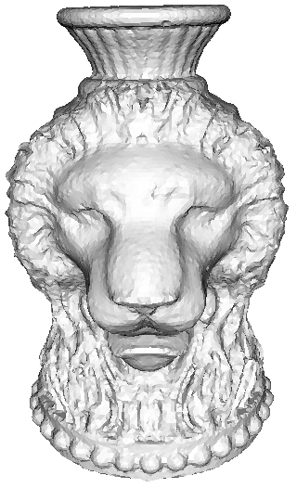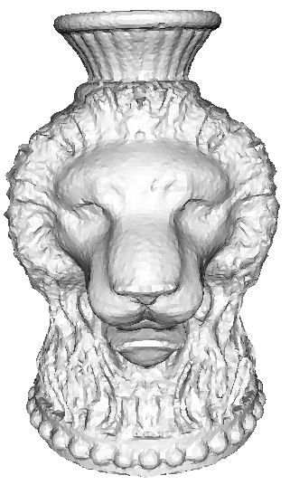
Original mesh non-obtuse mesh smoothed non-obtuse mesh point to point point to point different weights

 | Max distance | Mean distance
Point to point distance same weight | 0.008053 | 0.000547
Point to plane distance different weight | 0.007872 | 0.000545
The errors of the results.
Method:
1. same weight: toward to the closest points for all the vertices.
2. different weight: toward to the closest points for all the feature vertices, and others toward the centroid.

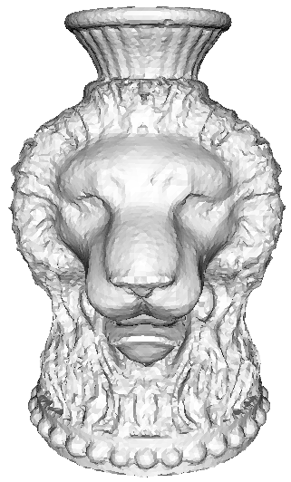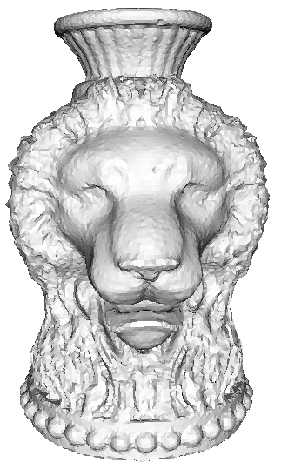
Original mesh First Iteration Second Iteration Third Iteration

 | Max distance | Mean distance
First Iteration | 0.007872 | 0.000545
Second Iteration | 0.007608 | 0.000536
Third Iteration | 0.007501 | 0.000534

